Year 5 (2021-2022) NYS 21CCLC

Annual Evaluation Report Template

**Please Note:** Text in this template that is new or modified compared with the Year 4 template appears in maroon type.

**Purpose of this Document**

This Year 5 Annual Evaluation Report (AER) Template and Guide for evaluators of local 21st CCLC programs in New York State was developed at the request of the **State Program Coordinator.**

It is recognized, as stated in the Evaluation Manual, that “Evaluation first and foremost should be useful to the program managers at all levels of the system…” and that “The Annual Report’s primary function is to present findings on the degree to which…objectives were met.” The Evaluation Manual further specifies that the AER should report on the study methodology, findings, and recommendations and conclusions.

While these represent the report’s “primary” functions, they do not reflect its only purpose. The AER also serves to inform NYSED Project Managers, Resource Center Support Specialists, and the Statewide Evaluator about program performance and accomplishments, which help guide the monitoring review and technical assistance processes. Many of the components of this report are directly aligned with NYSED policies and program expectations that are the focus of the monitoring visits that all programs receive. These alignments are highlighted throughout this template with references to **required indicators and evidence** in the revised Site Monitoring Visit Report (“SMV Report”).[1] ***Because NYSED and the Resource Centers review a program’s AERs before each visit, information provided in this report that aligns with those indicators can be used to fulfill the documentation requirements of these visits, which will continue into Round 8.***

Additional purposes of this report include helping to inform NYSED and the State Evaluator about trends across sub-grantees, which help to guide NYSED’s policy decisions, as well as its mandated reporting to the U.S. Department of Education. In short, the AER supports program improvement at both the state and local levels, and contributes to evidence that the federal government needs to make funding decisions.

The purpose of this report guide and template is to clearly identify, and to organize within a consistent structure, the information that is necessary for each of the above stakeholders. The template has been designed with the varying needs of these different stakeholders in mind. It is designed to strike a compromise between the brevity and accessibility that program managers require, and the depth of detail that state and federal stakeholders require. Summaries or graphics that would be useful to program staff can always be included within the comments of each section or in the appendices.

Please note that NYSED, the Resource Centers, and the State Evaluation Team are acutely aware of the ongoing challenges created by the COVID-19 pandemic. While the State Coordinator has stated that programs are expected to return to their original in-person programming, some redesign of programming models and activities – and even project goals – may still be necessary. Please refer to NYSED’s email of October 8, 2021 (sent from EMSC) outlining circumstances in which virtual programming may be allowable or required, and whether formal modifications would be required.

Use the “Explain” column in the Evaluation Plan tables, and other narrative sections of the report, to explain where the program and the evaluation were affected by these conditions, as well as any strategies that were used to address the challenges.

***General Guidelines for Completing this Document***

* *Results should be reported primarily at the program level;* however, if there is a lot of variation in results among sites, or if there are one or more “outlier” sites that do not fit the consortium level summary, these variations should also be reported. In addition, if different performance indicators, activities and/or assessments are used at different sites, these differences should be made explicit in Section 2 (Evaluation Plan and Year 5 Results).
* *Additional guidelines and instructions are provided for each section below. Please read them carefully.*
* *Please provide any content that is in PDF format (logic model, appendices, etc.) as attachments to the original document; images copied into this Word document do not convert to PDF well.*
* If respondents are concerned that data-heavy appendices would be overwhelming to their client, the optional Comments after each section can be used to provide a narrative summary, graphics, etc. as desired.

Please contact the State Evaluation Team with any questions. Thank you for your cooperation.

**Round 7 New York State 21st CCLC State Evaluation Team:**

**Jonathan Tunik,** Project Director

**Lily Corrigan,** Project Associate

**Nora Phelan,** Project Associate

**Dr. Nina Gottlieb,** Senior Research Consultant

*21CEval@measinc.com* | 1-800-330-1420 x203

Table of Contents

I. Project Information 2

II. Evaluation Plan & Results 3

a. Sample Evaluation Plan and Results Tables 4

b. Evaluation Plan and Results Tables 7

III. Observation Results 22

a. First visit 23

b. Second visit: 24

IV. Logic Model (LM) *and/or* Theory of Change Model (ToC) 25

Guidelines for Logic Models 25

V. Conclusions & Recommendations 30

a. Status of the implementation of recommendations from the previous year; AND

documented or perceived impacts of implementing those recommendations, if known 30

b. Strategies to help ensure that evaluation findings were used to inform program improvement. 30

c. Conclusions and recommendations based on the current year’s evaluation findings 30

d. Conclusions and recommendations based on evaluation findings from prior year objectives and indicators that could not be addressed until the current year due to pending data, if applicable 30

VI. Sustainability 31

VII. Appendices 32

# Project Information

| **Program Name** |  | | | |
| --- | --- | --- | --- | --- |
| **Project Number** | 0187-21- __ __ __ __ | | | |
| **Name of Lead Agency** |  | | | |
| **Name of Program Director** |  | | | |
| **Name(s) of Participating Site(s) and grade level(s) served at each site** | Site 1: _________________________________________ Grade(s) Served: ____________________________  Site 2: _________________________________________ Grade(s) Served: ____________________________  Site 3: _________________________________________ Grade(s) Served: ____________________________  Site 4: _________________________________________ Grade(s) Served: ____________________________  Site 5: _________________________________________ Grade(s) Served: ____________________________  Site 6: _________________________________________ Grade(s) Served: ____________________________  Site 7: _________________________________________ Grade(s) Served: ____________________________  Site 8: _________________________________________ Grade(s) Served: ____________________________  Site 9: _________________________________________ Grade(s) Served: ____________________________  Site 10: ________________________________________ Grade(s) Served: ____________________________  Site 11: ________________________________________ Grade(s) Served: ____________________________  Site 12: ________________________________________ Grade(s) Served: ____________________________ | | | |
| **Target Enrollment** | Total (Program-wide): | ____________________ | Actual # at/above 30 hours | ____________________ |
| **Evaluator Name and Company** |  | | | |
| **Evaluator Phone and Email** |  | | | |

# Evaluation Plan & Results

* Use the tables below to identify your program objectives, performance indicators (PIs) of success, evaluation and measurement plan, and results of your evaluation data collection and analysis for Year 5. Additional space is provided to report on Year 5 results that could not be reported last year.
* Add rows, and copy and paste the sections provided below, as many times as needed in order to accommodate all of your program’s objectives and PIs. ***Enter only one PI per row***, so as to make clear how it aligns with responses regarding target populations, SMART criteria, supporting activities, *etc*.
* This table is derived from the Template for Goals & Objectives in your grant proposal. ***If the activities and measurability of the PIs indicate a strong adherence to this original plan (plus any approved modifications), then this completed table may be used by grantees as evidence to support compliance with SMV Indicator E-3(a):*** “Adherence to the Program’s Grant Proposal”.
* If you have an existing table that includes some of the information below, you may copy and paste it at the end of this section or attach as an appendix. *You must then reference the appended table(s)* by writing “See Appendix X” or “See table below” in the appropriate columns, and then *complete all additional columns* that require information not included in your original table(s).
* Column instructions and definitions for the Evaluation Plan tables:

Space for reporting aActivities to support program objectives and PIs must be described; space is provided immediately below each objective for this purpose. If there are activities that are unique to specific PIs, they should be described in the row underneath the relevant PI. . You may list activity titles, or attach a list (in any format) as an appendix, and reference here.

**Col. A, B, D – *PIs, Target Populations and PI Measures:*** Specify in the comments box whether any of these were modified from the original grant proposal, and if so, whether the modifications required approval, and when they were approved.

**Col. B – *Target Populations:*** Students, parents, grade levels, sub-groups [e.g. special education], specific activity participants, *etc.* as applicable.

**Col. C – *SMART Criteria:*** Evaluators are asked here to assess whether they believe each of the established PIs are SMART (as defined below). If not, include an explanation in the comments of why not, and any plans to modify the PI.

**SMART** stands for: **Specific:** targets a specific, clearly defined area of improvement for a specific target group; **Measurable:** states a defined outcome that can be assessed, and how it is to be assessed, including instruments and analyses [which can be indicated in Columns E and F]. (SMART indicators can include qualitative assessment); **Achievable:** realistic given baseline conditions and available resources; **Relevant:** aligned to program mission, program activities, school day academics, GPRA indicators, *etc*. [note however that PIs are not *required* to be aligned with GPRA indicators]; **Time-bound:** specifies when the goal will be achieved [most will be annual].

**Col. D – *PI Measures:*** Data collection instruments and methodsused to assess success of the PI; *e.g.* surveys, observations, interviews, focus groups, report cards, attendance rosters, behavior/disciplinary records, state assessments, other skills assessments, *etc.* Indicate the title if a published instrument is used.

**Col. E – *Analyses:*** Analyses of the above measures used to determine whether the PI was met. Be sure to include specific results that directly assess the PI.

**Col. F – *Response Rate/% With Data:*** These measures are defined as the number of individuals for whom data/information was obtained, divided by the total number in the target population for whom the PI was specified. Note that the PI target population may be smaller than the total number of program participants, for example in activities that are not designed for all students, or if the PI is specified only for students attending a minimum number of hours.

**Col. G – *Was PI Met?*** As mentioned, it is understood that the pandemic may still have an impact on meeting or measuring many PIs and Objectives – options for these responses are still included. IMPORTANT: A designation of “Partial” can only be used to indicate that a Performance Indicator (PI) was fully met in at least one site, but not at all sites. “Progress towards” the PI, or “almost” meeting the indicator, should not be counted as partially met, although such details are useful, and are welcome in the comments sections. Make sure that assessments of whether PIs were met are aligned with how the PI is defined. (For example, if the PI specifies improvement, it is not sufficient to report only on end-of-year performance.) If a PI is not *measurable* (per Col. C), use the Not Measurable option here, but you can still provide relevant findings for context.

**All Columns -** Any PIs from the prior year that could not be reported in that year’s AER (e.g. due to pending district data) must now be reported in the “**Prior Year PIs”** subsection following each sub-objective.

## *Sample* Evaluation Plan and Results Tables

| **Objective 1: 21st CCLCs will offer a range of high-quality educational, developmental, and recreational services for students and their families.** |
| --- |
| **Sub-Objective 1.1**: Core educational services. 100% of Centers will offer high quality services in core academic areas, e.g., reading and literacy, mathematics, and science. |

| ***Sample* Program Objective 1.1-1 (specify): *ELA enrichment program offered to all students below proficient*** | | | | | | | | |
| --- | --- | --- | --- | --- | --- | --- | --- | --- |
| ***Sample* Describe activity(ies) to support this program objective here:** | | | | | | | | |
| ***- ELA Skills Through Leadership; - ELA Support for SIFE*** | | | | | | | | |
| **(A)**  ***Sample* Performance Indicator(s)** **(PI)** of success | **(B)**  ***Sample* Target Population(s)** | **(C)**  ***Sample* PI Meets SMART Criteria?**  **(Y/N)** | **(D)**  ***Sample* PI Measures**  data collection instruments & methods | **(E)**  ***Sample* Describe the analysis conducted,**  Include any longitudinal assessments conducted beyond one program year. | **(F)**  ***Sample* Response Rate/**  **% With Complete Data**  (if applicable): | | **(G)**  ***Sample***  **Was this PI Met? Select One:**  **\*Yes**  **\*Partial**  **\*Not Met due to pandemic**  **\*Not Met for other reasons**  ***\*Not measurable (see column C)***  **\*Not measured due to pandemic**  **\*Not measured for other reasons**  **\*Data pending** | **(H)**  ***Sample* EXPLAIN:**  **If Yes, No or Partial:** present results (expressed in the same metric as the PI)  **If Partial,** indicate# of sites where PI was *fully* met.  **If data pending,** indicatewhen data expected.  **If not measured or not measurable,** explain why not.  **If not met due to pandemic,** explain why not. |
| ***ELA enrichment programs offered 3 hours/day, 3 days/week for 30 weeks annually*** | ***Students in grades 4-8 who were below proficient in ELA in spring 2021*** | ***Y*** | ***- Program schedule***  ***- Fall evaluator observation summary*** | ***- Review of scheduled dates, days and hours***  ***- fall observations verify existence of programs*** | ***NA*** | | ***Partial*** | ***Both activities offered for 3 hrs/day X 3 days/wk at Site A, At Site B, ELA through Leadership met full schedule but ELA for SIFE only 2 hrs/day.*** |
| ***If needed*, describe activity(ies) specific to the above Performance Indicator here:** | | | | | | | | |
| ***600 students who were rated as below proficient in baseline ELA on spring 2021 state assessment attend at least 30 hours of ELA programming annually*** | ***Students who were below proficient on spring 2021 ELA exam.*** | ***Y*** | ***- spring ’21 ELA exams***  ***- attendance rosters*** | ***Review of:***  ***- spring ’21 ELA scores***  ***- count of #s attending >30 hrs by ELA scores*** | ***# targeted by PI: Total grade 4-8 students below proficient enrolled in ELA activities = 500***  ***# w data: 500 [# with completed spring ’21 ELA scores and records of hours of program attendance]***  ***[% with data = 100%]*** | ***Not met*** | | ***All 500 students at Sites A and B (combined) who were below proficient attended at least 30 hours at one of these programs; but attendance fell below the target of 600 students due to total program participation rates falling below the target.*** |
| **If needed, describe activity(ies) specific to the above Performance Indicator here:** | | | | | | | | |
| **Comments: Modifications from proposal, reasons for modifications, explanations of PIs not meeting SMART criteria, challenges encountered due to pandemic, etc.**  ***- Objective 1.1, second PI: because of difficulties meeting the program-wide participation target, higher-performing students were also recruited, but could not be counted in the defined target population for this PI.*** | | | | | | | | |

| **Objective 2: Participants of 21st CCLC Programs will demonstrate educational and social benefits and exhibit positive behavioral changes.** |
| --- |
| **Sub-Objective 2.1: Achievement.** Students regularly participating in the program will show continuous improvement in achievement through measures such as test scores, grades and/or teacher reports. |

| ***Sample* Program Objective 2.1-1 (specify): *Participants attending ELA enrichment improve their ELA performance*** | | | | | | | |
| --- | --- | --- | --- | --- | --- | --- | --- |
| ***Sample* Describe activity(ies) to support this program objective here:** | | | | | | | |
| ***- ELA Skills Through Leadership; - ELA Support for SIFE*** | | | | | | | |
| **(A)**  ***Sample* Performance Indicator(s)** **(PI)** of success | **(B)**  ***Sample* Target Population(s)** | **(C)**  ***Sample* PI Meets SMART Criteria?**  **(Y/N)** | **(D)**  ***Sample* PI Measures**  data collection instruments & methods | **(E)**  ***Sample* Describe the analysis conducted,**  Include any longitudinal assessments conducted beyond one program year. | **(F)**  ***Sample* Response Rate/**  **% With Complete Data**  (if applicable): | **(G)**  ***Sample***  **Was this PI Met? Select One:**  **\*Yes**  **\*Partial**  **\*Not Met due to pandemic**  **\*Not Met for other reasons**  ***\*Not measurable (see column C)***  **\*Not measured due to pandemic**  **\*Not measured for other reasons**  **\*Data pending** | **(H)**  ***Sample* EXPLAIN:**  **If Yes, No or Partial:** present results (expressed in the same metric as the PI)  **If Partial,** indicate# of sites where PI was *fully* met.  **If data pending,** indicatewhen data expected.  ***If not measured or not measurable, explain why not.***  **If not met due to pandemic,** explain why not. |
| ***80% of grade 4-8 participants who scored below proficient at baseline on the spring 2021 ELA exam, and attended 30+ hours of ELA activities, score at/above proficient on the Spring 2022 ELA test*** | ***Grade 4-8 students who scored below proficient in ELA in spring 2021*** | ***Y*** | ***- spring ’21 and spring ’22 ELA tests***  ***- activity attendance rosters*** | ***#/% of target group at/above proficient, spring ’21*** | ***# targeted by PI: 450 [among 500 grade 4-8 in ELA programs who were rated as below proficient at baseline, 450* attended ELA activity for 30+ hrs]**  ***# w data: [Pending]*** | ***Data Pending*** | ***Spring ’22 ELA data expected ca. August 2022*** |
| ***Sample* Comments on Program Objective: Modifications from proposal, reasons for modifications, explanations of PIs not meeting SMART criteria, challenges encountered due to pandemic, etc.**  ***- Y4 PI was not “SMART” - Not specific (did not specify how participants would be defined as “struggling”); program submitted a program modification to change this PI for SY 2021-22 to make it Specific.*** | | | | | | | |

| ***Sample* PRIOR Year PIs for Objective 2.1-1 [needed only if not reported last year]** | | | | | | | |
| --- | --- | --- | --- | --- | --- | --- | --- |
| ***Sample* Describe prior year activity(ies) to support this program objective here:** | | | | | | | |
| ***- ELA Skills Through Leadership; - ELA Support for SIFE*** | | | | | | | |
| **(A)**  ***Sample* Performance Indicator(s)** **(PI)** of success | **(B)**  ***Sample* Target Population(s)** | **(C)**  ***Sample* PI Meets SMART Criteria?**  **(Y/N)** | **(D)**  ***Sample* PI Measures**  data collection instruments & methods | **(E)**  ***Sample* Describe the analysis conducted,**  Include any longitudinal assessments conducted beyond one program year. | **(F)**  ***Sample* Response Rate/**  **% With Complete Data**  (if applicable): | **(G)**  ***Sample***  **Was this PI Met? Select One:**  **\*Yes**  **\*Partial**  **\*Not Met due to pandemic**  **\*Not Met for other reasons**  ***\*Not measurable (see column C)***  **\*Not measured due to pandemic**  **\*Not measured for other reasons**  **\*Data pending** | **(H)**  ***Sample* EXPLAIN:**  **If Yes, No or Partial:** present results (expressed in the same metric as the PI)  **If Partial,** indicate# of sites where PI was *fully* met.  **If data pending,** indicatewhen data expected.  ***If not measured or not measurable, explain why not.***  **If not met due to pandemic,** explain why not. |
| ***80% of struggling participants score at/above proficient in spring 2021*** | ***Students who were struggling in ELA in SY 2019-20*** | ***N*** | ***-spring ’21 NYS ELA exam***  ***- attendance rosters*** | ***#/% of target group at/above proficient, spring ’21*** | ***# targeted by PI: 512 students participated in ELA programs***  ***# w data:All participating students completed spring ’21 ELA exam***  ***[% with complete data= 100%]*** | ***Not measurable*** | ***Among the 512 target students with complete data, 420 (82%) scored above proficient on spring 2021 ELA test. Because the PI did not define which ones were “struggling,” however, this result cannot be considered as evidence of meeting the PI.*** |
| **Comments on Program Objective: Modifications from proposal, reasons for modifications, explanations of PIs not meeting SMART criteria, challenges encountered due to pandemic, etc.** | | | | | | | |

# 

## Evaluation Plan and Results Tables

*Enter your program’s data here.*

| **Objective 1: 21st CCLCs will offer a range of high-quality educational, developmental, and recreational services for students and their families.** |
| --- |

| **Sub-Objective 1.1**: Core educational services. 100% of Centers will offer high quality services in core academic areas, e.g., reading and literacy, mathematics, and science. | | | | | | | |
| --- | --- | --- | --- | --- | --- | --- | --- |
| **Program Objective 1.1-1 (specify):** | | | | | | | |
| **Describe activity(ies) to support this program objective here:** | | | | | | | |
|  | | | | | | | |
| **(A)**  **Performance Indicator(s)** **(PI)** of success | **(B)**  **Target Population(s)** | **(C)**  **PI Meets SMART Criteria?**  **(Y/N)** | **(D)**  **PI Measures**  data collection instruments & methods | **(E)**  **Describe the analysis conducted,**  Include any longitudinal assessments conducted beyond one program year. | **(F)**  **Response Rate/**  **% With Complete Data**  (if applicable): | **(G)**  **Was this PI Met? Select One:**  **\*Yes**  **\*Partial**  **\*Not Met due to pandemic**  **\*Not Met for other reasons**  ***\*Not measurable (see column C)***  **\*Not measured due to pandemic**  **\*Not measured for other reasons**  **\*Data pending** | **(H)**  **EXPLAIN:**  **If Yes, No or Partial:** present results (expressed in the same metric as the PI)  **If Partial,** indicate# of sites where PI was *fully* met.  **If data pending,** indicatewhen data expected.  ***If not measured or not measurable, explain why not.***  **If not met due to pandemic,** explain why not. |
|  |  |  |  |  | # targeted by PI: ___  # w data: ___ |  |  |
| ***If needed*, describe activity(ies) specific to the above Performance Indicator here:** | | | | | | | |
|  |  |  |  |  | # targeted by PI: ___  # w data: ___ |  |  |
| ***If needed*, describe activity(ies) specific to the above Performance Indicator here:** | | | | | | | |
| **Comments on Program Objective: Modifications from proposal, reasons for modifications, explanations of PIs not meeting SMART criteria, challenges encountered due to pandemic, etc.** | | | | | | | |

| **PRIOR Year Objective 1.1-1 [Specify if changed]:** | | | | | | | |
| --- | --- | --- | --- | --- | --- | --- | --- |
| **PRIOR Year PIs for Objective 1.1-1 [report in table below only if not reported last year]** | | | | | | | |
| **Describe prior year activity(ies) to support this program objective here:** | | | | | | | |
|  | | | | | | | |
| **(A)**  **Performance Indicator(s) (PI)** of success | **(B)**  **Target Population(s)** | **(C)**  **PI Meets SMART Criteria?**  **(Y/N)** | **(D)**  **PI Measures**  data collection instruments & methods | **(E)**  **Describe the analysis conducted,**  Include any longitudinal assessments conducted beyond one program year. | **(F)**  **Response Rate/**  **% With Complete Data**  (if applicable): | **(G)**  **Was this PI Met? Select One:**  **\*Yes**  **\*Partial**  **\*Not Met due to pandemic**  **\*Not Met for other reasons**  ***\*Not measurable (see column C)***  **\*Not measured due to pandemic**  **\*Not measured for other reasons**  **\*Data pending** | **(H)**  **EXPLAIN:**  **If Yes, No or Partial:** present results (expressed in the same metric as the PI)  **If Partial,** indicate# of sites where PI was *fully* met.  **If data pending,** indicatewhen data expected.  ***If not measured or not measurable, explain why not.***  **If not met due to pandemic,** explain why not. |
|  |  |  |  |  | # targeted by PI: ___  # w data: ___ |  |  |
| ***If needed*, describe activity(ies) specific to the above Performance Indicator here:** | | | | | | | |
|  |  |  |  |  | # targeted by PI: ___  # w data: ___ |  |  |
| ***If needed*, describe activity(ies) specific to the above Performance Indicator here:** | | | | | | | |
| **Comments on PRIOR Year Program Objective/PIs: Modifications from proposal, reasons for modifications, explanations of PIs not meeting SMART criteria, challenges encountered due to pandemic, etc.** | | | | | | | |

| **Sub-Objective 1.2**: **Enrichment and support activities.** 100% of Centers will offer enrichment and youth development activities such as nutrition and health, art, music, technology and recreation. |
| --- |

| **Program Objective 1.2-1 (specify):** | | | | | | | |
| --- | --- | --- | --- | --- | --- | --- | --- |
| **Describe activity(ies) to support this program objective here:** | | | | | | | |
| **(A)**  **Performance Indicator(s)** **(PI)** of success | **(B)**  **Target Population(s)** | **(C)**  **PI Meets SMART Criteria?**  **(Y/N)** | **(D)**  **PI Measures**  data collection instruments & methods | **(E)**  **Describe the analysis conducted,**  Include any longitudinal assessments conducted beyond one program year. | **(F)**  **Response Rate/**  **% With Complete Data**  (if applicable): | **(G)**  **Was this PI Met? Select One:**  **\*Yes**  **\*Partial**  **\*Not Met due to pandemic**  **\*Not Met for other reasons**  ***\*Not measurable (see column C)***  **\*Not measured due to pandemic**  **\*Not measured for other reasons**  **\*Data pending** | **(H)**  **EXPLAIN:**  **If Yes, No or Partial:** present results (expressed in the same metric as the PI)  **If Partial,** indicate# of sites where PI was *fully* met.  **If data pending,** indicatewhen data expected.  ***If not measured or not measurable, explain why not.***  **If not met due to pandemic,** explain why not. |
|  |  |  |  |  | # targeted by PI: ___  # w data: ___ |  |  |
| ***If needed*, describe activity(ies) specific to the above Performance Indicator here:** | | | | | | | |
|  |  |  |  |  | # targeted by PI: ___  # w data: ___ |  |  |
| ***If needed*, describe activity(ies) specific to the above Performance Indicator here:** | | | | | | | |
| **Comments on Program Objective: Modifications from proposal, reasons for modifications, explanations of PIs not meeting SMART criteria, challenges encountered due to pandemic, etc.** | | | | | | | |

| **PRIOR Year Objective 1.2-1 [Specify if changed]:** | | | | | | | |
| --- | --- | --- | --- | --- | --- | --- | --- |
| **PRIOR Year PIs for Objective 1.2-1 [report in table below only if not reported last year]** | | | | | | | |
| **Describe prior year activity(ies) to support this program objective here:** | | | | | | | |
|  | | | | | | | |
| **(A)**  **Performance Indicator(s)** **(PI)** of success | **(B)**  **Target Population(s)** | **(C)**  **PI Meets SMART Criteria?**  **(Y/N)** | **(D)**  **PI Measures**  data collection instruments & methods | **(E)**  **Describe the analysis conducted,**  Include any longitudinal assessments conducted beyond one program year. | **(F)**  **Response Rate/**  **% With Complete Data**  (if applicable): | **(G)**  **Was this PI Met? Select One:**  **\*Yes**  **\*Partial**  **\*Not Met due to pandemic**  **\*Not Met for other reasons**  ***\*Not measurable (see column C)***  **\*Not measured due to pandemic**  **\*Not measured for other reasons**  **\*Data pending** | **(H)**  **EXPLAIN:**  **If Yes, No or Partial:** present results (expressed in the same metric as the PI)  **If Partial,** indicate# of sites where PI was *fully* met.  **If data pending,** indicatewhen data expected.  ***If not measured or not measurable, explain why not.***  **If not met due to pandemic,** explain why not. |
|  |  |  |  |  | # targeted by PI: ___  # w data: ___ |  |  |
| ***If needed*, describe activity(ies) specific to the above Performance Indicator here:** | | | | | | | |
|  |  |  |  |  | # targeted by PI: ___  # w data: ___ |  |  |
| ***If needed*, describe activity(ies) specific to the above Performance Indicator here:** | | | | | | | |
| **Comments on PRIOR Year Program Objective/PIs: Modifications from proposal, reasons for modifications, explanations of PIs not meeting SMART criteria, challenges encountered due to pandemic, etc.** | | | | | | | |

| **Sub-Objective 1.3: Community Involvement.** 100% of Centers will establish and maintain partnerships within the community that continue to increase levels of community collaboration in planning, implementing and sustaining programs.[2] |
| --- |

| **Program Objective 1.3-1 (specify):** | | | | | | | |
| --- | --- | --- | --- | --- | --- | --- | --- |
| **Describe activity(ies) to support this program objective here:** | | | | | | | |
|  | | | | | | | |
| **(A)**  **Performance Indicator(s)** **(PI)** of success | **(B)**  **Target Population(s)** | **(C)**  **PI Meets SMART Criteria?**  **(Y/N)** | **(D)**  **PI Measures**  data collection instruments & methods | **(E)**  **Describe the analysis conducted,**  Include any longitudinal assessments conducted beyond one program year. | **(F)**  **Response Rate/**  **% With Complete Data**  (if applicable): | **(G)**  **Was this PI Met? Select One:**  **\*Yes**  **\*Partial**  **\*Not Met due to pandemic**  **\*Not Met for other reasons**  ***\*Not measurable (see column C)***  **\*Not measured due to pandemic**  **\*Not measured for other reasons**  **\*Data pending** | **(H)**  **EXPLAIN:**  **If Yes, No or Partial:** present results (expressed in the same metric as the PI)  **If Partial,** indicate# of sites where PI was *fully* met.  **If data pending,** indicatewhen data expected.  ***If not measured or not measurable, explain why not.***  **If not met due to pandemic,** explain why not. |
|  |  |  |  |  | # targeted by PI: ___  # w data: ___ |  |  |
| ***If needed*, describe activity(ies) specific to the above Performance Indicator here:** | | | | | | | |
|  |  |  |  |  | # targeted by PI: ___  # w data: ___ |  |  |
| ***If needed*, describe activity(ies) specific to the above Performance Indicator here:** | | | | | | | |
| **Comments on Program Objective: Modifications from proposal, reasons for modifications, explanations of PIs not meeting SMART criteria, challenges encountered due to pandemic, etc.** | | | | | | | |

| **PRIOR Year Objective 1.3-1 [Specify if changed]:** | | | | | | | |
| --- | --- | --- | --- | --- | --- | --- | --- |
| **PRIOR Year PIs for Objective 1.3-1 [report in table below only if not reported last year]** | | | | | | | |
| **Describe prior year activity(ies) to support this program objective here:** | | | | | | | |
|  | | | | | | | |
| **(A)**  **Performance Indicator(s)** **(PI)** of success | **(B)**  **Target Population(s)** | **(C)**  **PI Meets SMART Criteria?**  **(Y/N)** | **(D)**  **PI Measures**  data collection instruments & methods | **(E)**  **Describe the analysis conducted,**  Include any longitudinal assessments conducted beyond one program year. | **(F)**  **Response Rate/**  **% With Complete Data**  (if applicable): | **(G)**  **Was this PI Met? Select One:**  **\*Yes**  **\*Partial**  **\*Not Met due to pandemic**  **\*Not Met for other reasons**  ***\*Not measurable (see column C)***  **\*Not measured due to pandemic**  **\*Not measured for other reasons**  **\*Data pending** | **(H)**  **EXPLAIN:**  **If Yes, No or Partial:** present results (expressed in the same metric as the PI)  **If Partial,** indicate# of sites where PI was *fully* met.  **If data pending,** indicatewhen data expected.  ***If not measured or not measurable, explain why not.***  **If not met due to pandemic,** explain why not. |
|  |  |  |  |  | # targeted by PI: ___  # w data: ___ |  |  |
| ***If needed*, describe activity(ies) specific to the above Performance Indicator here:** | | | | | | | |
|  |  |  |  |  | # targeted by PI: ___  # w data: ___ |  |  |
| ***If needed*, describe activity(ies) specific to the above Performance Indicator here:** | | | | | | | |
| **Comments on PRIOR Year Program Objective/PIs: Modifications from proposal, reasons for modifications, explanations of PIs not meeting SMART criteria, challenges encountered due to pandemic, etc.** | | | | | | | |

| **Sub-Objective 1.4: Services to parents and other adult community members.** 100% of Centers will offer services to parents of participating children.[3] |
| --- |

| **Program Objective 1.4-1 (specify):** | | | | | | | |
| --- | --- | --- | --- | --- | --- | --- | --- |
| **Describe activity(ies) to support this program objective here:** | | | | | | | |
|  | | | | | | | |
| **(A)**  **Performance Indicator(s)** **(PI)** of success | **(B)**  **Target Population(s)** | **(C)**  **PI Meets SMART Criteria?**  **(Y/N)** | **(D)**  **PI Measures**  data collection instruments & methods | **(E)**  **Describe the analysis conducted,**  Include any longitudinal assessments conducted beyond one program year. | **(F)**  **Response Rate/**  **% With Complete Data**  (if applicable): | **(G)**  **Was this PI Met? Select One:**  **\*Yes**  **\*Partial**  **\*Not Met due to pandemic**  **\*Not Met for other reasons**  ***\*Not measurable (see column C)***  **\*Not measured due to pandemic**  **\*Not measured for other reasons**  **\*Data pending** | **(H)**  **EXPLAIN:**  **If Yes, No or Partial:** present results (expressed in the same metric as the PI)  **If Partial,** indicate# of sites where PI was *fully* met.  **If data pending,** indicatewhen data expected.  ***If not measured or not measurable, explain why not.***  **If not met due to pandemic,** explain why not. |
|  |  |  |  |  | # targeted by PI: ___  # w data: ___ |  |  |
| ***If needed*, describe activity(ies) specific to the above Performance Indicator here:** | | | | | | | |
|  |  |  |  |  | # targeted by PI: ___  # w data: ___ |  |  |
| ***If needed*, describe activity(ies) specific to the above Performance Indicator here:** | | | | | | | |
| **Comments on Program Objective: Modifications from proposal, reasons for modifications, explanations of PIs not meeting SMART criteria, challenges encountered due to pandemic, etc.** | | | | | | | |

| **PRIOR Year Objective 1.4-1 [Specify if changed]:** | | | | | | | |
| --- | --- | --- | --- | --- | --- | --- | --- |
| **PRIOR Year PIs for Objective 1.4-1 [needed only if not reported last year]** | | | | | | | |
| **Describe prior year activity(ies) to support this program objective here:** | | | | | | | |
|  | | | | | | | |
| **(A)**  **Performance Indicator(s)** **(PI)** of success | **(B)**  **Target Population(s)** | **(C)**  **PI Meets SMART Criteria?**  **(Y/N)** | **(D)**  **PI Measures**  data collection instruments & methods | **(E)**  **Describe the analysis conducted,**  Include any longitudinal assessments conducted beyond one program year. | **(F)**  **Response Rate/**  **% With Complete Data**  (if applicable): | **(G)**  **Was this PI Met? Select One:**  **\*Yes**  **\*Partial**  **\*Not Met due to pandemic**  **\*Not Met for other reasons**  ***\*Not measurable (see column C)***  **\*Not measured due to pandemic**  **\*Not measured for other reasons**  **\*Data pending** | **(H)**  **EXPLAIN:**  **If Yes, No or Partial:** present results (expressed in the same metric as the PI)  **If Partial,** indicate# of sites where PI was *fully* met.  **If data pending,** indicatewhen data expected.  ***If not measured or not measurable, explain why not.***  **If not met due to pandemic,** explain why not. |
|  |  |  |  |  | # targeted by PI: ___  # w data: ___ |  |  |
| ***If needed*, describe activity(ies) specific to the above Performance Indicator here:** | | | | | | | |
|  |  |  |  |  | # targeted by PI: ___  # w data: ___ |  |  |
| ***If needed*, describe activity(ies) specific to the above Performance Indicator here:** | | | | | | | |
| **Comments on PRIOR Year Program Objective/PIs: Modifications from proposal, reasons for modifications, explanations of PIs not meeting SMART criteria, challenges encountered due to pandemic, etc.** | | | | | | | |

| **Sub-Objective 1.5: Extended hours.** More than 75% of Centers will offer services at least 15 hours a week on average and provide services when school is not in session, such as during the summer and on holidays. |
| --- |

| **Program Objective 1.5-1 (specify):** | | | | | | | |
| --- | --- | --- | --- | --- | --- | --- | --- |
| **Describe activity(ies) to support this program objective here:** | | | | | | | |
|  | | | | | | | |
| **(A)**  **Performance Indicator(s)** **(PI)** of success | **(B)**  **Target Population(s)** | **(C)**  **PI Meets SMART Criteria?**  **(Y/N)** | **(D)**  **PI Measures**  data collection instruments & methods | **(E)**  **Describe the analysis conducted,**  Include any longitudinal assessments conducted beyond one program year. | **(F)**  **Response Rate/**  **% With Complete Data**  (if applicable): | **(G)**  **Was this PI Met? Select One:**  **\*Yes**  **\*Partial**  **\*Not Met due to pandemic**  **\*Not Met for other reasons**  ***\*Not measurable (see column C)***  **\*Not measured due to pandemic**  **\*Not measured for other reasons**  **\*Data pending** | **(H)**  **EXPLAIN:**  **If Yes, No or Partial:** present results (expressed in the same metric as the PI)  **If Partial,** indicate# of sites where PI was *fully* met.  **If data pending,** indicatewhen data expected.  ***If not measured or not measurable, explain why not.***  **If not met due to pandemic,** explain why not. |
|  |  |  |  |  | # targeted by PI: ___  # w data: ___ |  |  |
| ***If needed*, describe activity(ies) specific to the above Performance Indicator here:** | | | | | | | |
|  |  |  |  |  | # targeted by PI: ___  # w data: ___ |  |  |
| ***If needed*, describe activity(ies) specific to the above Performance Indicator here:** | | | | | | | |
| **Comments on Program Objective: Modifications from proposal, reasons for modifications, explanations of PIs not meeting SMART criteria, challenges encountered due to pandemic, etc.** | | | | | | | |

| **PRIOR Year Objective 1.5-1 [Specify if changed]:** | | | | | | | |
| --- | --- | --- | --- | --- | --- | --- | --- |
| **PRIOR Year PIs for Objective 1.5-1 [needed only if not reported last year]** | | | | | | | |
| **Describe prior year activity(ies) to support this program objective here:** | | | | | | | |
|  | | | | | | | |
| **(A)**  **Performance Indicator(s)** **(PI)** of success | **(B)**  **Target Population(s)** | **(C)**  **PI Meets SMART Criteria?**  **(Y/N)** | **(D)**  **PI Measures**  data collection instruments & methods | **(E)**  **Describe the analysis conducted,**  Include any longitudinal assessments conducted beyond one program year. | **(F)**  **Response Rate/**  **% With Complete Data**  (if applicable): | **(G)**  **Was this PI Met? Select One:**  **\*Yes**  **\*Partial**  **\*Not Met due to pandemic**  **\*Not Met for other reasons**  ***\*Not measurable (see column C)***  **\*Not measured due to pandemic**  **\*Not measured for other reasons**  **\*Data pending** | **(H)**  **EXPLAIN:**  **If Yes, No or Partial:** present results (expressed in the same metric as the PI)  **If Partial,** indicate# of sites where PI was *fully* met.  **If data pending,** indicatewhen data expected.  ***If not measured or not measurable, explain why not.***  **If not met due to pandemic,** explain why not. |
|  |  |  |  |  | # targeted by PI: ___  # w data: ___ |  |  |
| ***If needed*, describe activity(ies) specific to the above Performance Indicator here:** | | | | | | | |
|  |  |  |  |  | # targeted by PI: ___  # w data: ___ |  |  |
| ***If needed*, describe activity(ies) specific to the above Performance Indicator here:** | | | | | | | |
| **Comments on PRIOR Year Program Objective/PIs: Modifications from proposal, reasons for modifications, explanations of PIs not meeting SMART criteria, challenges encountered due to pandemic, etc.** | | | | | | | |

| **Objective 2: Participants of 21st CCLC Programs will demonstrate educational and social benefits and exhibit positive behavioral changes.** |
| --- |
| **Sub-Objective 2.1: Achievement.** Students regularly participating in the program will show continuous improvement in achievement through measures such as test scores, grades and/or teacher reports. |

| **Program Objective 2.1-1 (specify):** | | | | | | | |
| --- | --- | --- | --- | --- | --- | --- | --- |
| **Describe activity(ies) to support this program objective here:** | | | | | | | |
|  | | | | | | | |
| **(A)**  **Performance Indicator(s)** **(PI)** of success | **(B)**  **Target Population(s)** | **(C)**  **PI Meets SMART Criteria?**  **(Y/N)** | **(D)**  **PI Measures**  data collection instruments & methods | **(E)**  **Describe the analysis conducted,**  Include any longitudinal assessments conducted beyond one program year. | **(F)**  **Response Rate/**  **% With Complete Data**  (if applicable): | **(G)**  **Was this PI Met? Select One:**  **\*Yes**  **\*Partial**  **\*Not Met due to pandemic**  **\*Not Met for other reasons**  ***\*Not measurable (see column C)***  **\*Not measured due to pandemic**  **\*Not measured for other reasons**  **\*Data pending** | **(H)**  **EXPLAIN:**  **If Yes, No or Partial:** present results (expressed in the same metric as the PI)  **If Partial,** indicate# of sites where PI was *fully* met.  **If data pending,** indicatewhen data expected.  ***If not measured or not measurable, explain why not.***  **If not met due to pandemic,** explain why not. |
|  |  |  |  |  | # targeted by PI: ___  # w data: ___ |  |  |
| ***If needed*, describe activity(ies) specific to the above Performance Indicator here:** | | | | | | | |
|  |  |  |  |  | # targeted by PI: ___  # w data: ___ |  |  |
| ***If needed*, describe activity(ies) specific to the above Performance Indicator here:** | | | | | | | |
| **Comments on Program Objective: Modifications from proposal, reasons for modifications, explanations of PIs not meeting SMART criteria, challenges encountered due to pandemic, etc.** | | | | | | | |

***Note that the Objective 2 tables might serve as a supplemental source of evidence documenting “Students’ satisfaction and perception of program impact,” helping to support grantees’ compliance with SMV Indicator H-4.***

| **PRIOR Year Objective 2.1-1 [Specify if changed]:** | | | | | | | |
| --- | --- | --- | --- | --- | --- | --- | --- |
| **PRIOR Year PIs for Objective 2.1-1 [needed only if not reported last year]** | | | | | | | |
| **Describe prior year activity(ies) to support this program objective here:** | | | | | | | |
|  | | | | | | | |
| **(A)**  **Performance Indicator(s)** **(PI)** of success | **(B)**  **Target Population(s)** | **(C)**  **PI Meets SMART Criteria?**  **(Y/N)** | **(D)**  **PI Measures**  data collection instruments & methods | **(E)**  **Describe the analysis conducted,**  Include any longitudinal assessments conducted beyond one program year. | **(F)**  **Response Rate/**  **% With Complete Data**  (if applicable): | **(G)**  **Was this PI Met? Select One:**  **\*Yes**  **\*Partial**  **\*Not Met due to pandemic**  **\*Not Met for other reasons**  ***\*Not measurable (see column C)***  **\*Not measured due to pandemic**  **\*Not measured for other reasons**  **\*Data pending** | **(H)**  **EXPLAIN:**  **If Yes, No or Partial:** present results (expressed in the same metric as the PI)  **If Partial,** indicate# of sites where PI was *fully* met.  **If data pending,** indicatewhen data expected.  ***If not measured or not measurable, explain why not.***  **If not met due to pandemic,** explain why not. |
|  |  |  |  |  | # targeted by PI: ___  # w data: ___ |  |  |
| ***If needed*, describe activity(ies) specific to the above Performance Indicator here:** | | | | | | | |
|  |  |  |  |  | # targeted by PI: ___  # w data: ___ |  |  |
| ***If needed*, describe activity(ies) specific to the above Performance Indicator here:** | | | | | | | |
| **Comments on PRIOR Year Program Objective/PIs: Modifications from proposal, reasons for modifications, explanations of PIs not meeting SMART criteria, challenges encountered due to pandemic, etc.** | | | | | | | |

| **Sub-Objective 2.2: Behavior.** Regular attendees in the program will show continuous improvements on measures such as school attendance, classroom performance and decreased disciplinary actions or other adverse behaviors. |
| --- |

| **Program Objective 2.2-1 (specify):** | | | | | | | |
| --- | --- | --- | --- | --- | --- | --- | --- |
| **Describe activity(ies) to support this program objective here:** | | | | | | | |
|  | | | | | | | |
| **(A)**  **Performance Indicator(s)** **(PI)** of success | **(B)**  **Target Population(s)** | **(C)**  **PI Meets SMART Criteria?**  **(Y/N)** | **(D)**  **PI Measures**  data collection instruments & methods | **(E)**  **Describe the analysis conducted,**  Include any longitudinal assessments conducted beyond one program year. | **(F)**  **Response Rate/**  **% With Complete Data**  (if applicable): | **(G)**  **Was this PI Met? Select One:**  **\*Yes**  **\*Partial**  **\*Not Met due to pandemic**  **\*Not Met for other reasons**  ***\*Not measurable (see column C)***  **\*Not measured due to pandemic**  **\*Not measured for other reasons**  **\*Data pending** | **(H)**  **EXPLAIN:**  **If Yes, No or Partial:** present results (expressed in the same metric as the PI)  **If Partial,** indicate# of sites where PI was *fully* met.  **If data pending,** indicatewhen data expected.  ***If not measured or not measurable, explain why not.***  **If not met due to pandemic,** explain why not. |
|  |  |  |  |  | # targeted by PI: ___  # w data: ___ |  |  |
| ***If needed*, describe activity(ies) specific to the above Performance Indicator here:** | | | | | | | |
|  |  |  |  |  | # targeted by PI: ___  # w data: ___ |  |  |
| ***If needed*, describe activity(ies) specific to the above Performance Indicator here:** | | | | | | | |
| **Comments on Program Objective: Modifications from proposal, reasons for modifications, explanations of PIs not meeting SMART criteria, challenges encountered due to pandemic, etc.** | | | | | | | |

| **PRIOR Year Objective 2.2-1 [Specify if changed]:** | | | | | | | |
| --- | --- | --- | --- | --- | --- | --- | --- |
| **PRIOR Year PIs for Objective 2.2-1 [needed only if not reported last year]** | | | | | | | |
| **Describe prior year activity(ies) to support this program objective here:** | | | | | | | |
|  | | | | | | | |
| **(A)**  **Performance Indicator(s)** **(PI)** of success | **(B)**  **Target Population(s)** | **(C)**  **PI Meets SMART Criteria?**  **(Y/N)** | **(D)**  **PI Measures**  data collection instruments & methods | **(E)**  **Describe the analysis conducted,**  Include any longitudinal assessments conducted beyond one program year. | **(F)**  **Response Rate/**  **% With Complete Data**  (if applicable): | **(G)**  **Was this PI Met? Select One:**  **\*Yes**  **\*Partial**  **\*Not Met due to pandemic**  **\*Not Met for other reasons**  ***\*Not measurable (see column C)***  **\*Not measured due to pandemic**  **\*Not measured for other reasons**  **\*Data pending** | **(H)**  **EXPLAIN:**  **If Yes, No or Partial:** present results (expressed in the same metric as the PI)  **If Partial,** indicate# of sites where PI was *fully* met.  **If data pending,** indicatewhen data expected.  ***If not measured or not measurable, explain why not.***  **If not met due to pandemic,** explain why not. |
|  |  |  |  |  | # targeted by PI: ___  # w data: ___ |  |  |
| ***If needed*, describe activity(ies) specific to the above Performance Indicator here:** | | | | | | | |
|  |  |  |  |  | # targeted by PI: ___  # w data: ___ |  |  |
| ***If needed*, describe activity(ies) specific to the above Performance Indicator here:** | | | | | | | |
| **Comments on PRIOR Year Program Objective/PIs: Modifications from proposal, reasons for modifications, explanations of PIs not meeting SMART criteria, challenges encountered due to pandemic, etc.** | | | | | | | |

| Provide a discussion of any particular strengths or limitations of above assessments or evaluation design, and describe any efforts or plans to minimize limitations (***Required*** if there were limitations).  (Optional): Additional comments on evaluation plan and Year 5 PI results. |
| --- |

# Site Visit and Observation Findings

In this section you are asked to provide data and findings from each of the two required annual evaluator visits per site, as specified in the Evaluation Manual. Also include here a discussion of any in-person or virtual observations you may have conducted, as well as a discussion of any circumstances resulting from the pandemic that may have interfered with your ability to conduct observations, and reasons why observations had to be conducted virtually (if any).

The specified purposes of these visits, as defined in the Evaluation Manual, remain the same, and include:

**First visit: observe program implementation fidelity (Evaluation Manual, pp. 17-18).** This visit includes verifying existence of, and *alignment* among,

* the grant proposal (including the Table for Goals and Objectives),
* logic model,
* calendar and schedule of activities,
* program timeline,
* program handbook,
* parental consent forms, and
* procedures for entering/documenting evaluation data.

This visit should also serve to identify any barriers to implementation.

**Second visit: conduct point of service quality reviews (Evaluation Manual, p. 29).** This visit, during which an observation instrument such as the Out of School Time Protocol (OST) or Out of School Time Protocol Adapted for Virtual Learning (OST-A) is completed for selected activities, focuses on activity content and structure (including environmental context, participation, and instructional strategies), relationship building and the quality of interpersonal relationships, and the degree to which activities focus on skill development and mastery.

***Note: evidence of completion of site visits is required for compliance with SMV Indicator H-1. (See Indicator H-1(c).)***

1. **First visit**

Append results from any observation protocols or separate reports you have prepared for your client, as applicable.[4]In addition, please provide here summaries of findings on **fidelity** **to program design** from the first required visit.

| Please specify approximate date(s) of *first* round of Year 5 visits (MM/YY): _____________________________________ |
| --- |

**Results:**

## Second visit:

Append results from any observation protocols or separate reports you have prepared for your client,[5] or paste on this page, any summaries of findings on **point of service quality review observations** from the second observationconducted as part of the program evaluation.

| Please specify approximate date(s) of *second* round of Year 5 visits and observations (MM/YY): _______________________________ |
| --- |

* Observation protocol used for point of service observations:[6]

❒ Out of School Time Protocol (OST)

❒ Out of School Time Protocol Adapted for Virtual Learning (OST-A)

❒ Other modified version of Out of School Time Protocol (attach a sample in Appendix)

❒ Other observation protocol (attach sample in Appendix, or if published, indicate name): _______________________________________

**Results:**

# Logic Model (LM) *and/or* Theory of Change Model (ToC)

Some evaluators have indicated that a Theory of Change, as an addition to, or in lieu of, a logic model, would be more meaningful than a logic model for their client. In this section, please provide whichever model(s) are most useful for your client. Theory of change should be aligned with the discussion of evidence-based research underpinning the program theory that was required by the RFP; it can be presented as a formal model, or it can be presented descriptively.

Please provide your most up-to-date logic and/or theory of change model(s), highlighting any modifications since last year.[7] Logic model templates and samples are provided below:

* **“Logic Model Components”** (below) describes the basic components that should be included, as well as some optional contextual factors.
* Following the “Components,” the **“Generic Logic Model Template”** shows one possible structure in more detail.
* The **“Sample Logic Model”** then shows an example of what an actual 21st CCLC program might look like. Additional logic model examples from actual programs in NYS accompany this AER template, included with permission of the Program Directors.

For a more in-depth discussion of how to create a logic model, refer to the Evaluation Manual, *Creating a Program Logic Model Based on the Program Theory* (pp. 22-24), and *Appendix 4:* *The Logic Model Process Deconstructed* (Appendix pp.8-13).

## Guidelines for Logic Models

* There is no one “correct” format for a logic model. It is the content that is important.
* Components of the logic model should align with your Evaluation Plan in Section II above:
  + Activities in your evaluation plan should align with activities in the logic model
  + Goals, objectives and/or performance indicators in your evaluation plan should align with outputs, and short-term and long-term outcomes in the logic model, as applicable.
* There can, however, be additional components of the logic model that are not part of the evaluation plan. For example:
  + Descriptions of administrative resources or activities that may not be directly addressed in your evaluation objectives.
  + You might also include one or more “ultimate” outcomes/impacts reflecting the fundamental purpose, motivation, or mission of your program, even if it is not something that is explicitly measured. They are typically more general statements than SMART goals – for example, “improving academic success,” or “creating productive citizens.”
* The Logic Model should do more than simply list inputs, activities, etc.; it should depict how these components relate to each other. The arrows can be read as meaning “leads to,” “supports,” “contributes to,” etc. It is important to note that the outcomes and impacts that 21st CCLC activities “contribute to” are virtually always also affected by numerous other factors.
* Logic models do not need to show measurable specifics – these details should be shown in the Evaluation Plan in Section II.

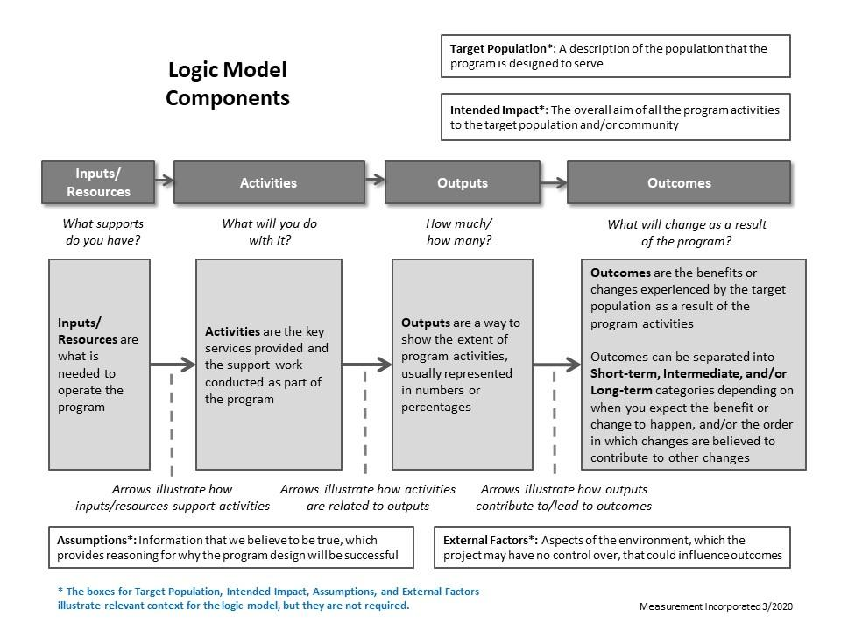

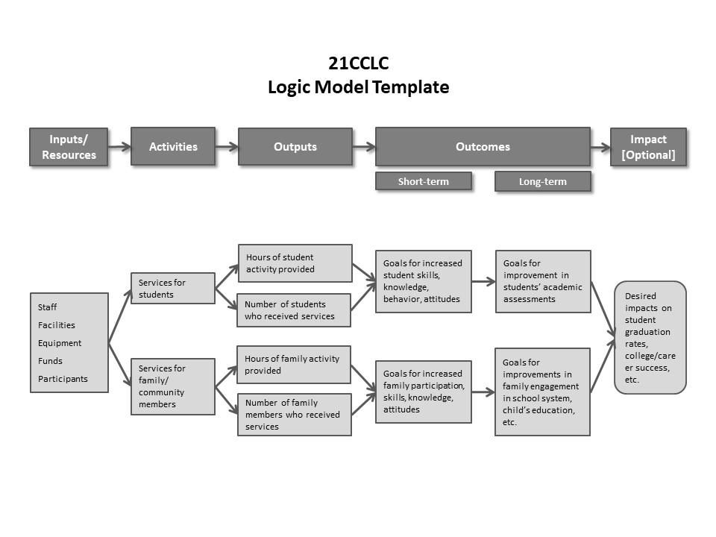

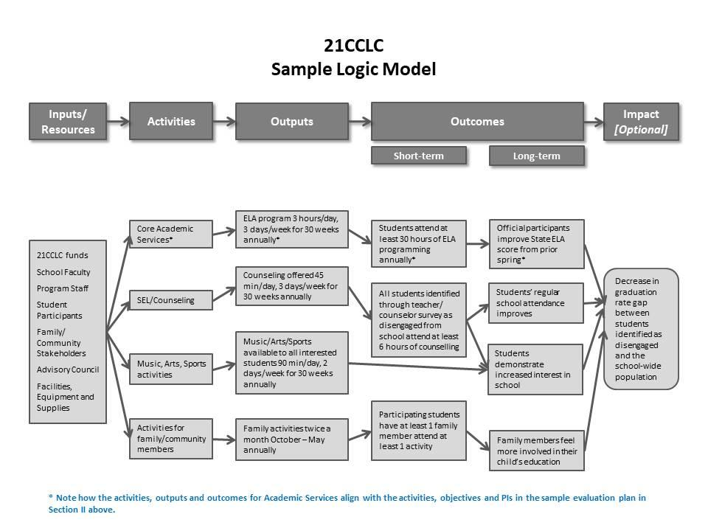

**COPY AND PASTE YOUR LOGIC MODEL HERE**; you can use the above “template” or example as a guide, or you can use another format, as long as it includes all components.

* Use the comments space below to summarize any aspects of the LM, and/or Theory of Change, that have changed since the prior program year,[8] or are still under development, and if so, why.

| **Comments:** |
| --- |

# Conclusions & Recommendations

Program’s successes and lessons learned based on evaluation findings**[9]**

## Status of the implementation of recommendations from the previous year;

## AND

## documented or perceived impacts of implementing those recommendations, if known

## Conclusions and recommendations based on the current year’s evaluation findings. Also include conclusions and recommendations based on evaluation findings from *prior* year objectives and indicators that could not be previously addressed due to pending data, if applicable.

## 

## Strategies to help ensure that evaluation findings were used to inform program improvement.

# Sustainability

Have any discussions or planning taken place around sustaining the program beyond expiration of the grant?

⬜ Yes ⬜ No

Briefly describe the status of your sustainability plan. (For example: Which key stakeholders have contributed to the plan? Has it been finalized, or is it still under discussion? Is there a general consensus as to how well the plan is likely to support continued programming in lieu of a renewed 21CCLC grant?)

Ifthere is at least a preliminary plan, please briefly list (potential) sustainability strategies here (bullet format is sufficient):

# Appendices

Required:

* Copies of any *locally developed* measurement tools/assessments (surveys,1 observation tools, *etc*.)
* Full, tabulated results of any quantitative assessment tools (surveys,[10] observation protocols, skills assessments, *etc*.) These tabulated results can also be used in lieu of copies of the original instrument as long as they include complete text of instructions, rating scales, questions, etc.

Optional:

* Sample of memo or weekly/monthly report used to share ongoing evaluation results/data with program[11]
* Any additional narrative, analysis, graphics or other information that did not fit into any section in this report that you would like to include

1. Retrieved from <http://p1232.nysed.gov/sss/documents/SiteMonitoringVisitReportPDF4.28.21.pdf>. Please keep your eyes on the SSS website for future updates to the SMV.

  
2. ***Note that this table might serve as a supplemental source of evidence documenting activities to engage and communicate with families, helping support grantees’ compliance with Indicators in SMV Section G, particularly G-3, G-5, G-6, and G-7.***
3. ***Note that this table might serve as a supplemental source of evidence documenting “Adult Learning Opportunities” helping to support grantees’ compliance with MV Indicator G-8(d).***
4. Copies of completed site observation protocols and/or other site visit summaries should be provided to program managers as a source of required supporting evidence to meet compliance for SMV Indicator H-1(c), “evidence of two site visits per site.”
5. Copies of completed site observation protocols and/or other site visit summaries should be provided to program managers as a source of required supporting evidence to meet compliance for SMV Indicator H-1(c), “evidence of two site visits per site.”
6. Note: As specified in SMV Indicator D-3, grantees are also required to conduct program activity implementation reviews, using a form consistent with the research-based OST (or OST-A) observation instrument. Evidence of the activities specified in Indicator D-3 [see D-3(a) and (b)] can be strengthened if the evaluator and grantee collaborate on learning from the findings of these similar point-of-service observations and grantee quality reviews.
7. ***Note: an up-to-date logic model is required for compliance with SMV Indicator H-2. (See Indicator H-2(b).)***
8. Note that annual reviews of the logic model are required, as per SMV Indicator H-2(b).
9. Note: as specified in SMV Indicator H-7, grantees are required to communicate evaluation findings to families and community stakeholders. Evidence of implementation of the activities specified in Indicator H-7(a) and (b) can be strengthened if the evaluator can help provide the grantee with a summary of sharable findings, such as reported in this summary.
10. Note: As specified in SMV Indicator H-4(a), local evaluators and program administrators are jointly responsible for administering annual surveys to student participants, and grantees are required to maintain documented evidence of this activity.
11. Note: As specified in SMV Indicator H-3(b), local evaluators and program administrators are jointly responsible for maintaining ongoing communication with each other, and grantees are required to maintain documented evidence of this activity.